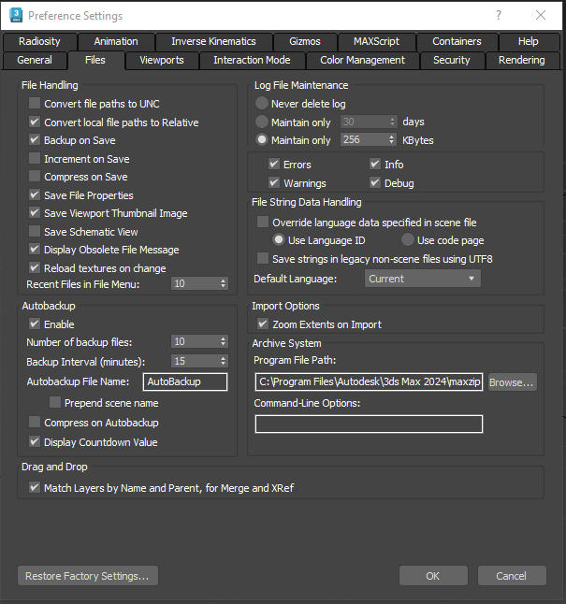



* Set local file path to relative

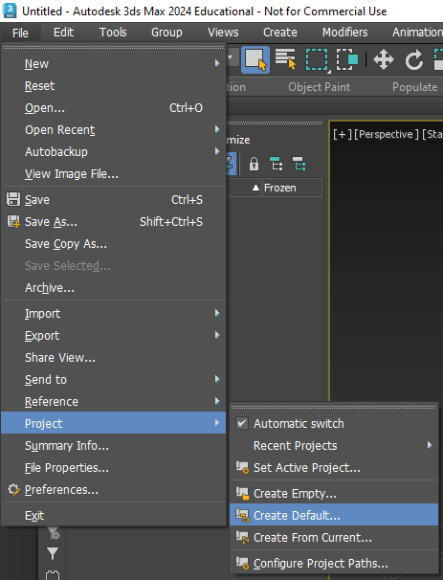

Creates the default pathway for our projects

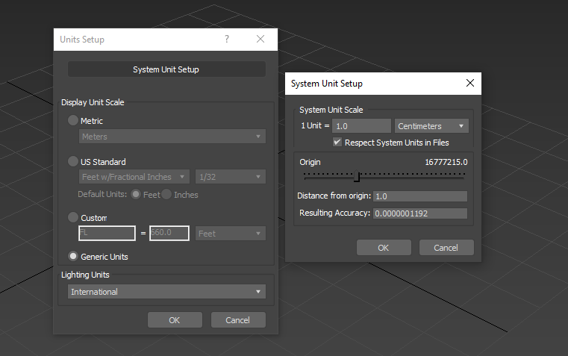

Changing the measurements from inches to centimeters

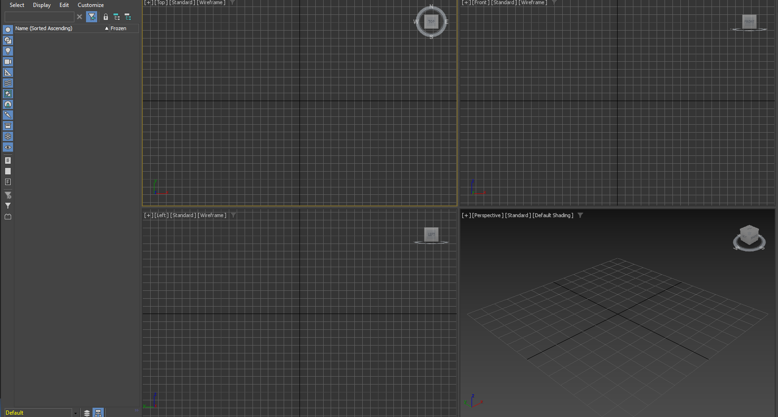

ALT+W allows us to see multiple angles of our project

adds a segment wherever you choose, more free form

Enables editing of edges

Chamfer = editing the curve from an edge

Connect = makes a more accurate segment between edges

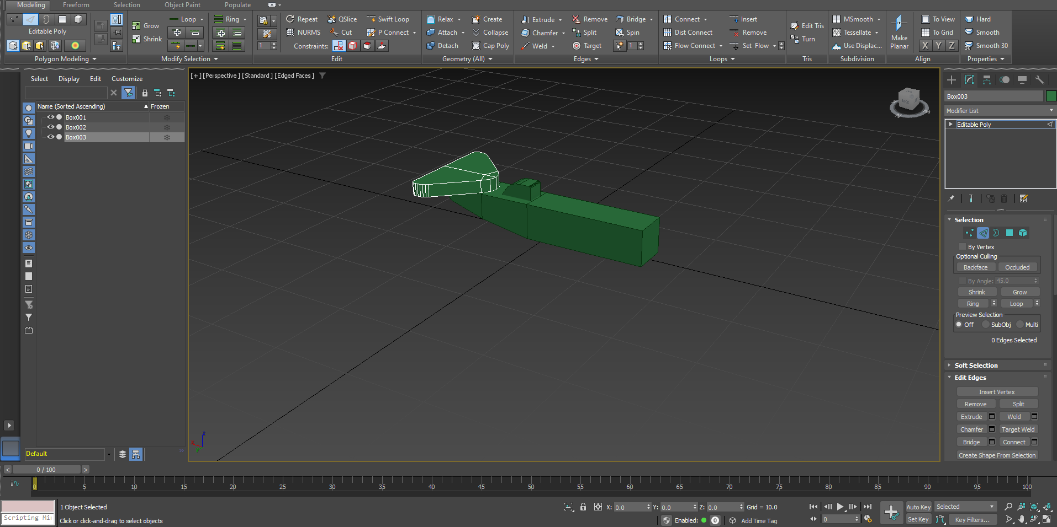

Progressively making my plane, creating one shape at a time and editing it to suit.

Experimenting with insets, bevels and extrusions

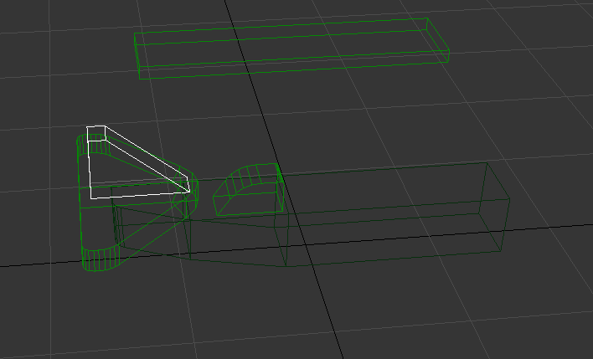

Wire frame mode (F3)

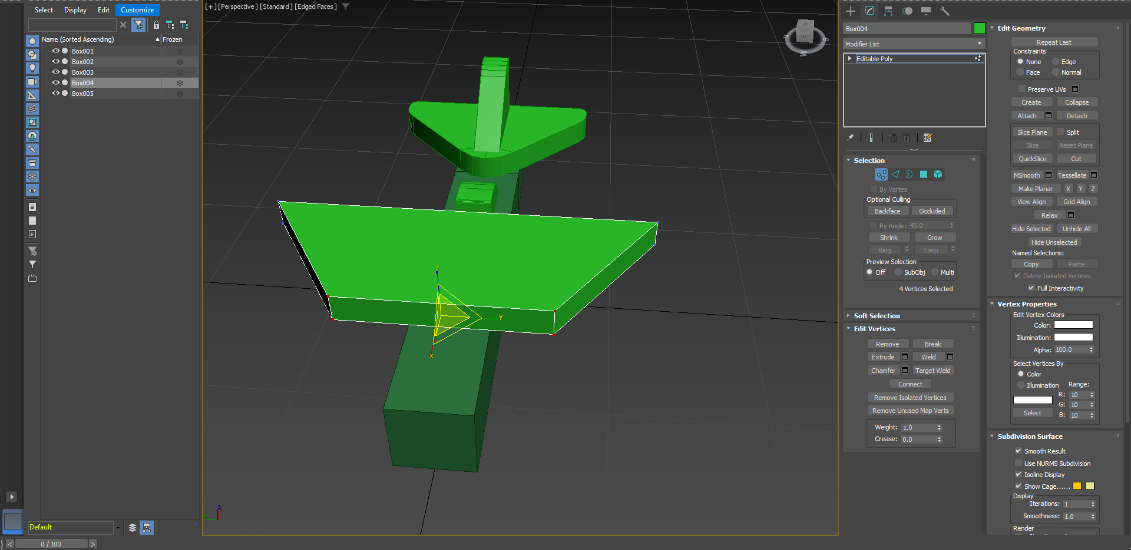

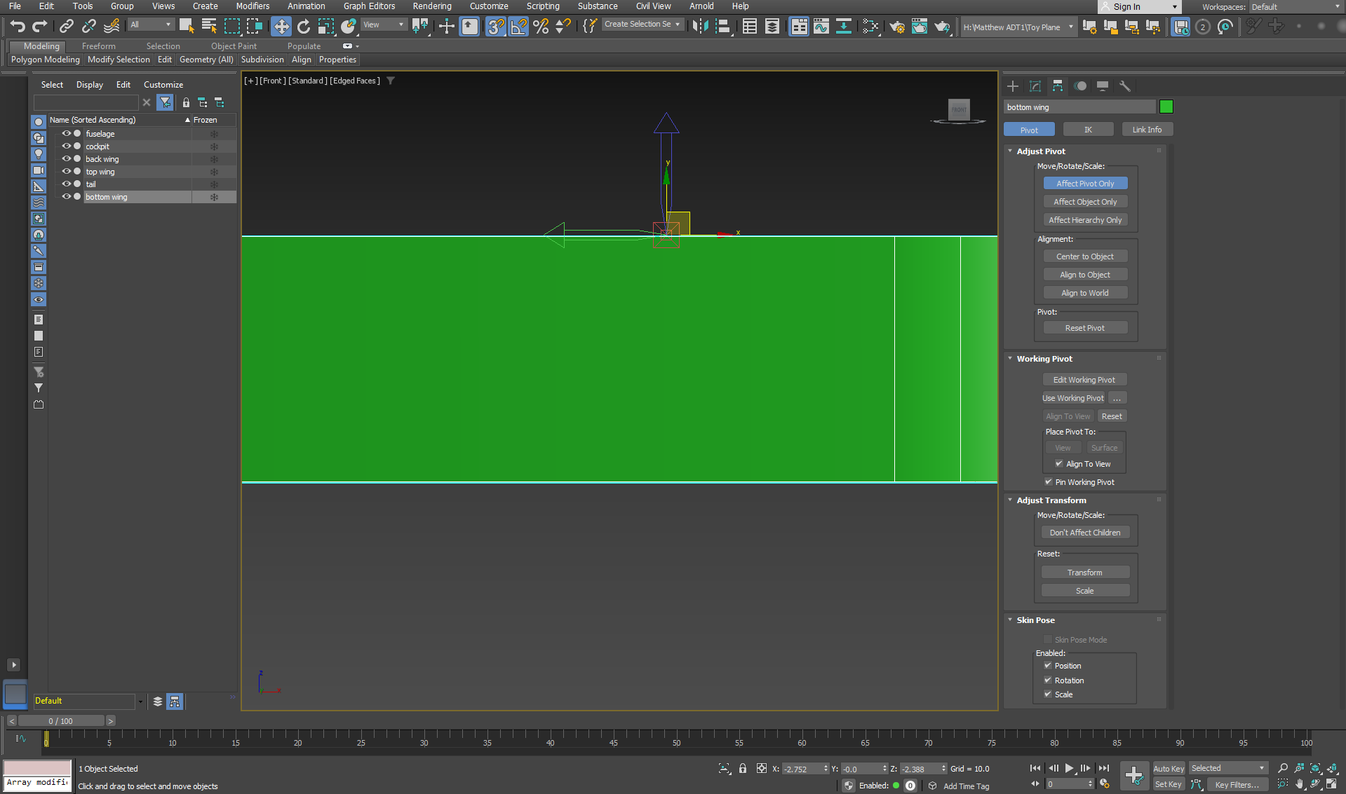

Hierarchy – affect pivot only ( will move the pivot but not the structure. Is good for when you are using lines to sculpt, place the pivot in the middle of where you want it to be mirrored

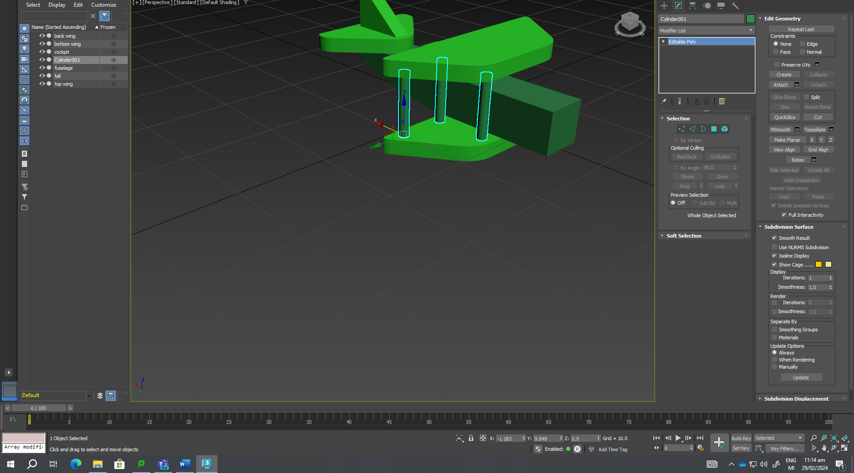

Attached 3 cylinders together (using the attach feature)

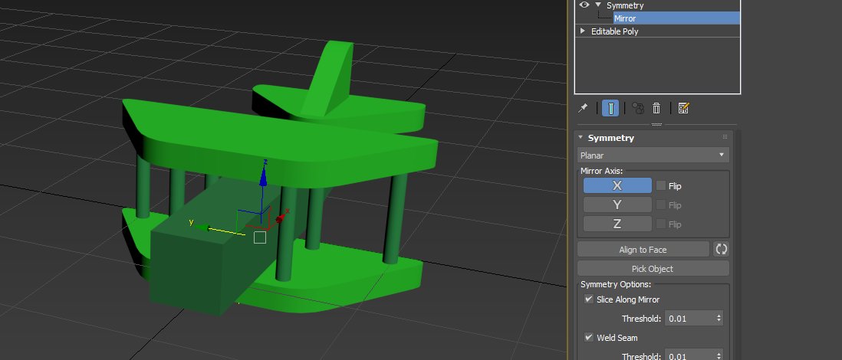

Symmetry, aligning 3 cylinders on both sides of my plane

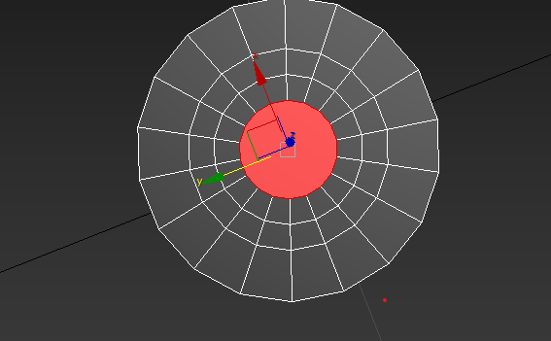

Shrink and grow options, grow will go outward and cover more area

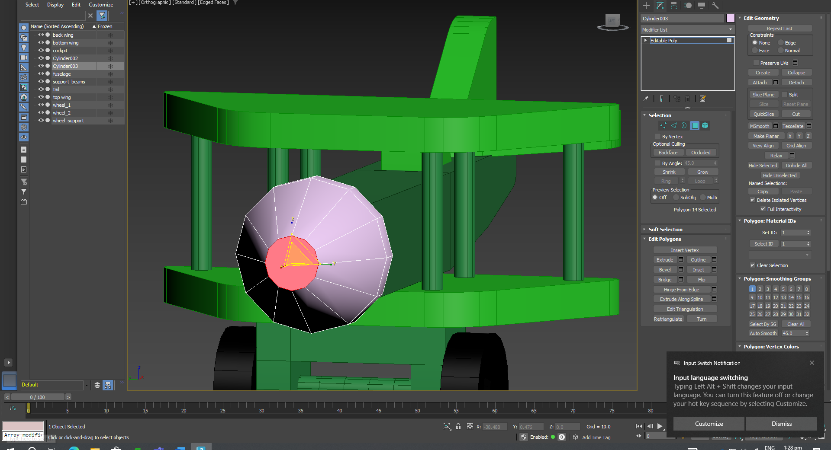

Able to hold ctrl+ click from poly to edge to choose the edges around the chosen poly prior\*

Finished plane model without wrapping

Attached all parts of my plane together

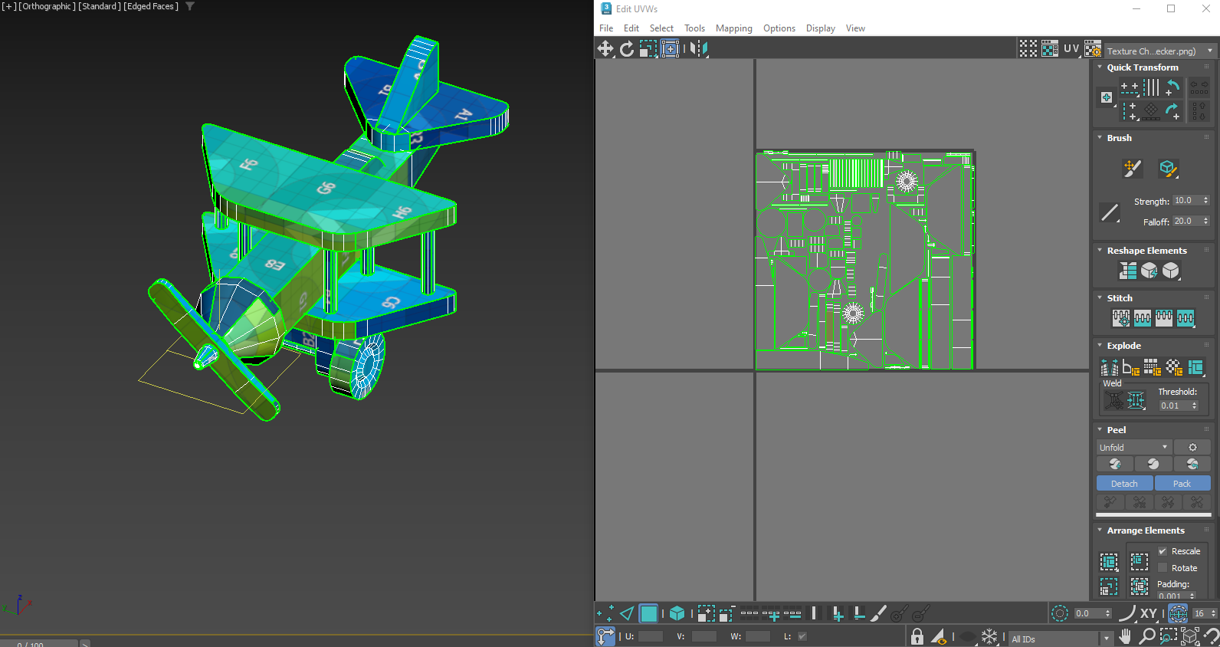

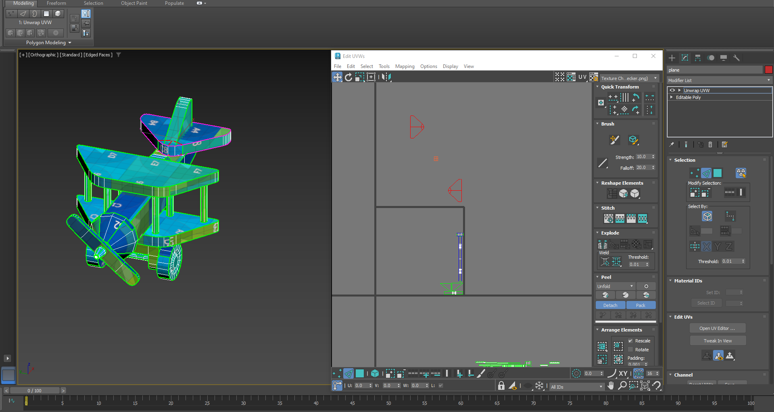

This is the process of unwrapping our plane

GOT SICK BEFORE FINISHING THE WRAPPING OF MY PLANE :’(

Create a loop on the top end, extrude but change from group to local normal

Warm up practices

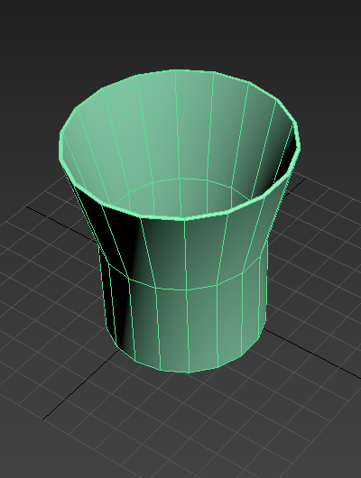

Shell modifier

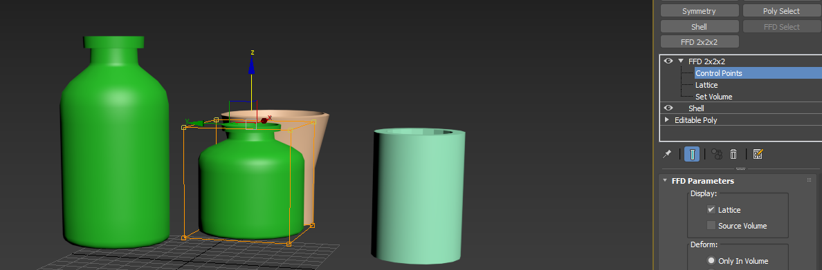

FFD 2x2x2 is good for changing the shape of your object after completion ( different variations of bottles etc)

Line tool useful for making 2D shapes and extrude to change into 3d

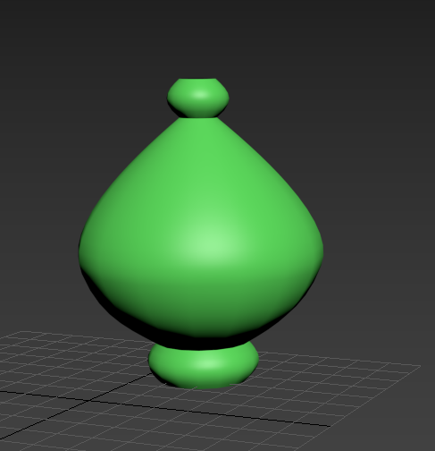

Started with a line, lathed to make it a 3d object

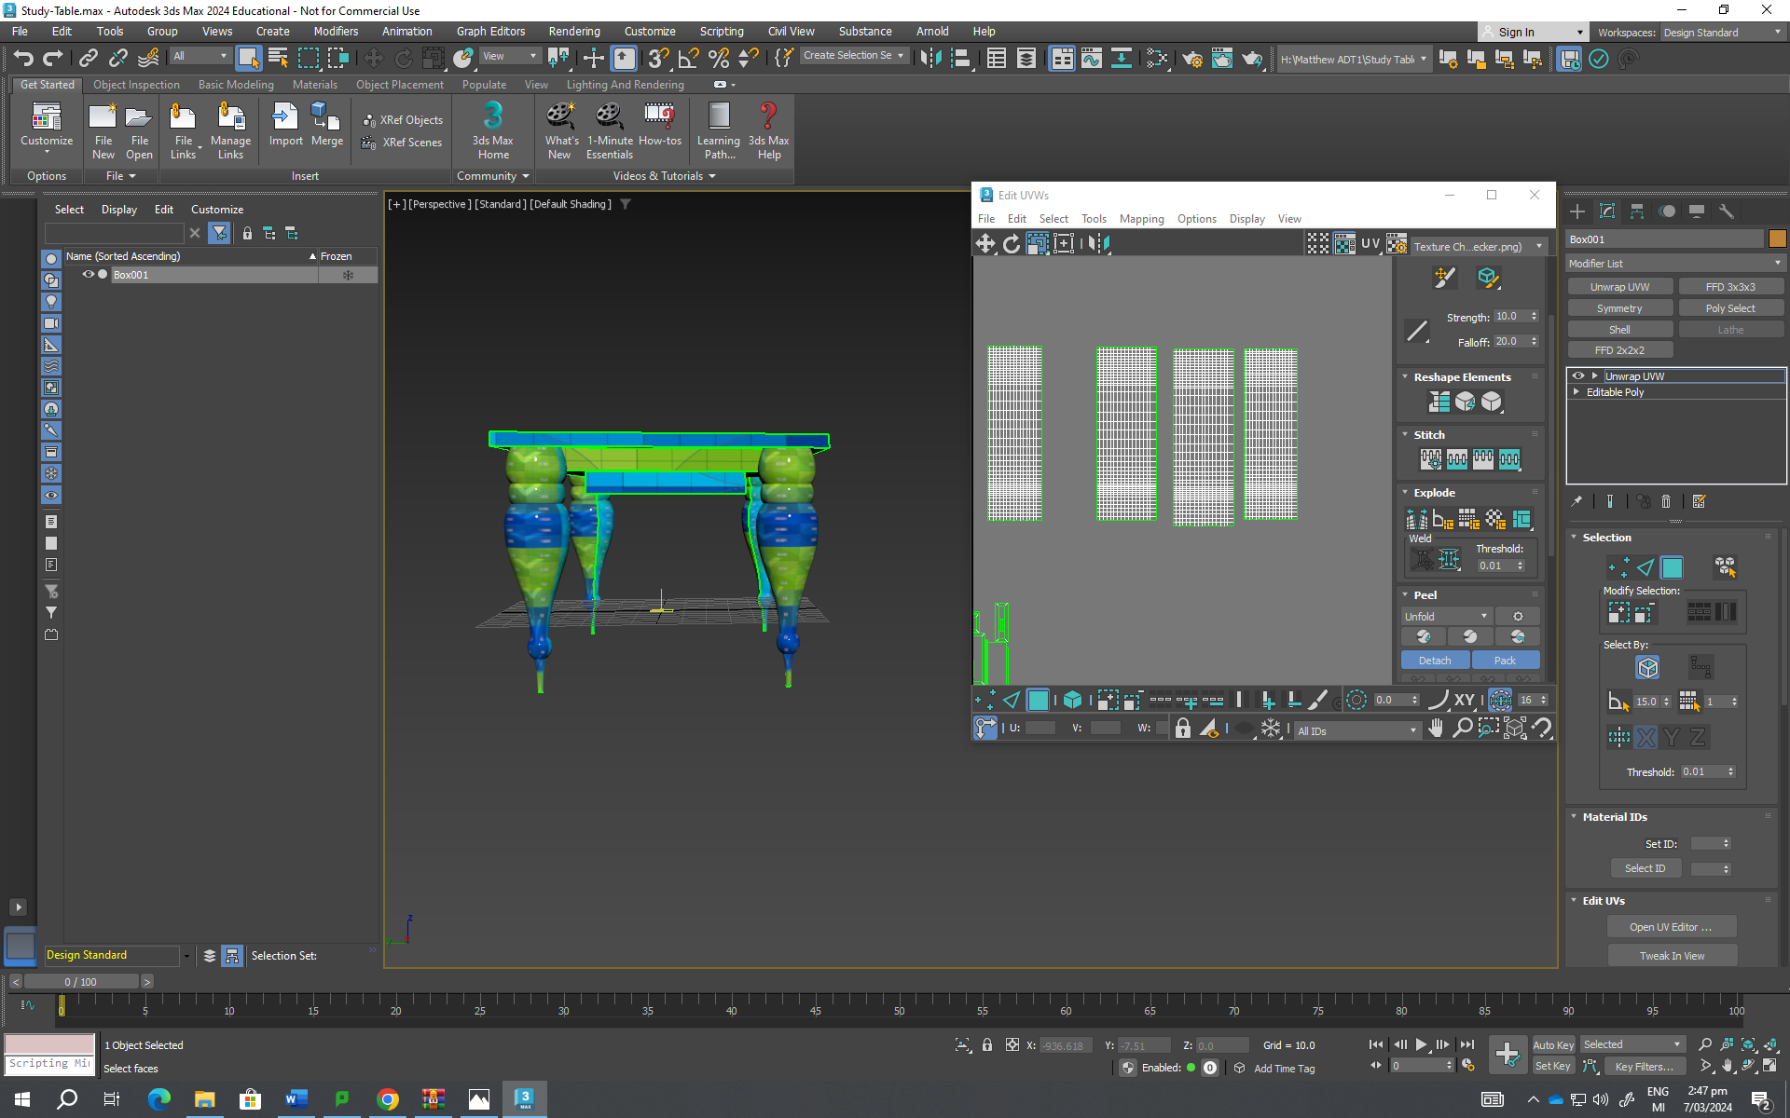

Process of unwrapping our table

Straighten tool

Select an edge on the leg and break, use to straighten objects that aren’t by default (round, not straight stuff)

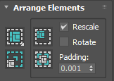

This is used to re pack the spread out parts of your model back into the texture box